Name: ___________________________ Date: ___________________ Period: __________

PROPERTIES OF MATTER PPT NOTES

What is Matter?
- _________________– anything that has _____________and ___________________
- Everything you can see and touch is made of _______________________
- Only things that aren’t matter are forms of energy – _______________ and _____________________
- https://www.brainpop.com/science/matterandchemistry/measuringmatter/preview.weml

Mass
- Mass – the __________________of ________________ in a substance or object.
- SI units – grams ________, kilograms_____________

Mass vs Weight
- The more _____________an object contains, the more it _______________.
- _____________________– a measure of the force of ___________________ pulling on an object.
- A ____________________is used to measure the force pulling down
- SI unit – _____________________ (N)
- Example: 1kg weighs 9.8 N (2.2 lb)

Volume
- Volume – the amount of ____________________matter takes up
- Liquids measured in ___________________ ________________________
- Irregular shaped objects use water ______________________________.
- Measured in ___________________, mL, m³, cm³

Displacement Method

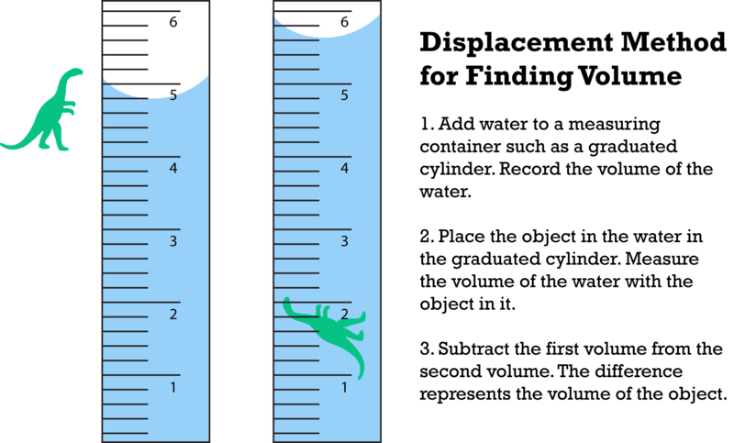

Properties of Matter
- Physical Properties
  - describe matter ____________________ changing its identity
- Examples
- _______________, shape, size, _________________, melting point, and boiling point

Density
- Density – ____________________property, represents how tightly ________________particles of matter are.
- D = Mass/Volume

Chemical Properties
- describe how a material will react to form _____________________ _________________
- Examples
  - ______________________(can burn)
  - can corrode (metals combine with metals dull, brittle
  - can sour
  - forms precipitate (solid forms from 2 liquids)
  - ________________ with acid
  - effervesces (forms _____________________of gas, NOT BOILING)

Recativity
- Reactivity – the ability of matter to _________________ __________________________ with other substances.
- Example –____________ reacting with___________ to produce rust.

