PHASES OF MATTER & PHASE CHANGES

- What is a solid?

- Describe how the particles are arranged in the solid phase.

- Here is how the particles look in the SOLID PHASE

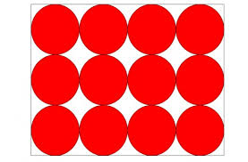

- What is a liquid?

- Describe how the particles are arranged in the liquid phase.

- Here’s how the particles look in the LIQUID PHASE
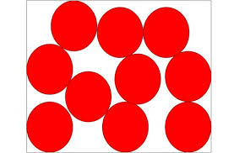

- What is a gas?

- Describe how the particles are arranged in the gas phase.

- Here’s how the particles look in the GAS PHASE.

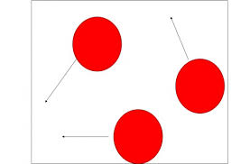

- What is the kinetic theory of matter?

Phase Changes Questions: Fill in the blanks for the following sentences on each phase change.
- The phase change when a SOLID turning into a LIQUID is called _____________________________________. During this phase change, temperature ___________________________. (increase/decrease/remains the same) As a substance goes from the solid phase to the liquid phase the speed of the particles ____________________________________. (increase/decrease/remains the same) During this phase change, energy is ____________________.
- The phase change when a LIQUID turning into a SOLID is called _____________________________________. During this phase change, temperature ___________________________. (increase/decrease/remains the same) As a substance goes from the liquid phase to the solid phase the speed of the particles ____________________________________. (increase/decrease/remains the same) During this phase change, energy is ____________________.
- The phase change when a LIQUID turning into a GAS is called _____________________________________. During this phase change, temperature ___________________________. (increase/decrease/remains the same) As a substance goes from the liquid phase to the gas phase the speed of the particles ____________________________________. (increase/decrease/remains the same) There are two types of vaporization, _____________________________________ and _____________________________________. _____________________________________ happens at the surface of the liquid. _____________________________________happens throughout the entire liquid when a substance reaches its _____________________________________. During this phase change, energy is ____________________.
- The phase change when a GAS turning into a LIQUID is called _____________________________________. During this phase change, temperature ___________________________. (increase/decrease/remains the same) As a substance goes from the gas phase to the liquid phase the speed of the particles ____________________________________. (increase/decrease/remains the same) During this phase change, energy is ____________________.
- The phase change when a SOLID turning into a GAS is called (without going to the liquid phase) _____________________________________. During this phase change, temperature ___________________________. (increase/decrease/remains the same) As a substance goes from the solid phase to the gas phase the speed of the particles ____________________________________. (increase/decrease/remains the same) During this phase change, energy is ____________________.
- The phase change when a GAS turning into a SOLID is called (without going to the liquid phase) _____________________________________. During this phase change, temperature ___________________________. (increase/decrease/remains the same) As a substance goes from the gas phase to the solid phase the speed of the particles ____________________________________. (increase/decrease/remains the same) During this phase change, energy is ____________________.

