Review #8: Motion
Part 1: Vocabulary

For each vocab word, indicate a “trigger” word from that term’s definition that helps you to remember that definition.

Distance ____________________ Velocity ____________________
Displacement ____________________ Frame of reference____________________
Relative motion ____________________ vector ____________________
Speed ____________________ instantaneous speed ____________________
Average speed ____________________ velocity ____________________
Acceleration ____________________ net force ____________________
Balanced force ____________________ free fall ____________________
Constant acceleration ____________________

Part 2: Intro to Motion

Answer the following questions using your notes.
- True or false: Distance and Displacement are the same. Explain your answer. ______________________________________________________________________________________________________________________________________________________________
- What does it mean when an object is traveling at a constant speed? ______________________________________________________________________________________________________________________________________________________________
- What is instantaneous speed? ______________________________________________________________________________________________________________________________________________________________
- When something is speeding up or slowing down, what is happening to its instantaneous speed? ______________________________________________________________________________________________________________________________________________________________
- When something is moving at a constant speed, what is happening to its instantaneous speed? ______________________________________________________________________________________________________________________________________________________________
- If a car is moving around a circular track at a constant speed, is its velocity changing? Explain. ______________________________________________________________________________________________________________________________________________________________
- If the acceleration is in the same direction as the velocity, is the acceleration positive or negative?
______________________________________________________________________________________________________________________________________________________________
- If the acceleration is in the opposite direction as the velocity, is the acceleration positive or negative? ______________________________________________________________________________________________________________________________________________________________
- What can you conclude about the acceleration of the object based upon the graph below? ______________________________________________________________________________________________________________________________________________________________

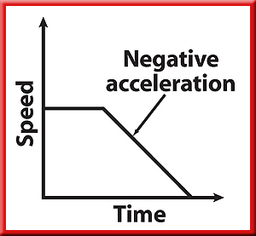

- What can you conclude about the speed of the object based upon the graph below? ______________________________________________________________________________________________________________________________________________________________

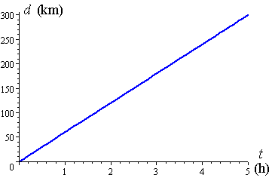

Part 3: Distance vs. Displacement

Answer the following questions using your knowledge of distance and displacement.
- A person walks 50 m North and then turns around and walks 35 m south. Then realizes they forgot their purse so walks another 60 m North. What is the person’s displacement? What is the person’s distance?

- If a person jogs down the street for 70 m and then gets tired and turns around and jogs another 70 m home. What is the person’s displacement? What is the person’s distance?

Part 4: Speed & Velocity

In the box below, write the equation for calculating velocity/speed. Then label the parts of the equation and what each variable is measured in.

v=____________________ measured in ____________________
d= ____________________ measured in ____________________
t= ____________________ measured in____________________
Complete the following problems. Make sure you are showing all work and putting your answer with correct units.
- An ant travels 75 cm in 6 s. What was the ant’s speed?

- You are in a car traveling an average speed of 60 km/h. The total trip is 240 km. How long does the trip take?

- A car is traveling at a constant speed of 30 m/s. If the car is moving for 25 s, how far did the car go?

Part 5: Acceleration

In the box below, write the equation for calculating acceleration. Then label the parts of the equation and what each variable is measured in.

a= ____________________ measured in ____________________
v_{f} = ____________________ measured in ____________________
v_{i}= ____________________ measured in____________________
t = ____________________ measured in____________________
Complete the following problems make sure that you are using the correct equation, showing all work and writing your answer with correct units.

- An object moves from rest to 9 m/s in 3 s. What is the acceleration of the object?

- A car slows from 16 m/s to 2 m/s in 3.5 s. What is the car’s acceleration?

- A ball is dropped from a cliff and has an acceleration of 9.8 m/s². How long will it take the ball to reach a speed of 24.5 m/s?

- A sprinter leaves the starting blocks with an acceleration of 4.5 m/s². Calculate the sprinter’s speed 2 s later.

