METEOROLOGY UNIT REVIEW

- Put the following notes in order and staple them together
  - Layers of Atmosphere Foldable
  - Intro to Climate PPT Notes
  - Meteorology PPT Notes
  - Air Masses & Fronts PPT Notes
  - Weather Map Lab
  - Greenhouse Effect PPT Notes

- Read through all notes & Highlight Important terms & Ideas

- Review game on Quia: http://www.quia.com/rr/1164556.html

- ESSAY: Relate the Coriolis effect to the ball on the merry go round.

  - Video Link: https://www.youtube.com/watch?v=_36MiCUS1ro
  - See photo below

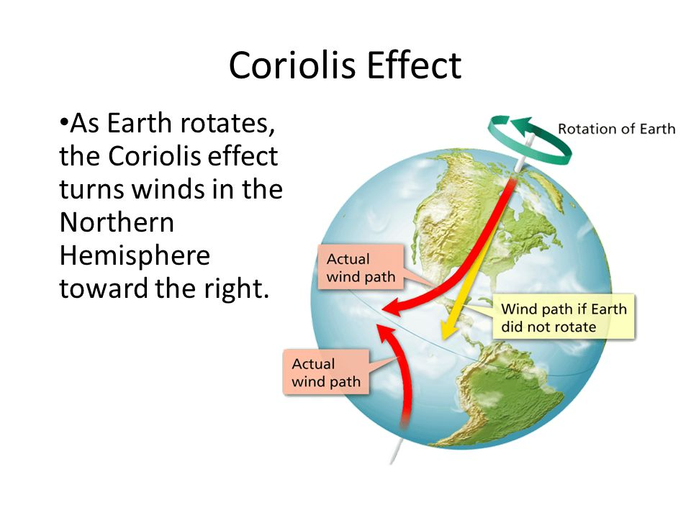

- Label the Global Winds on the following diagram. 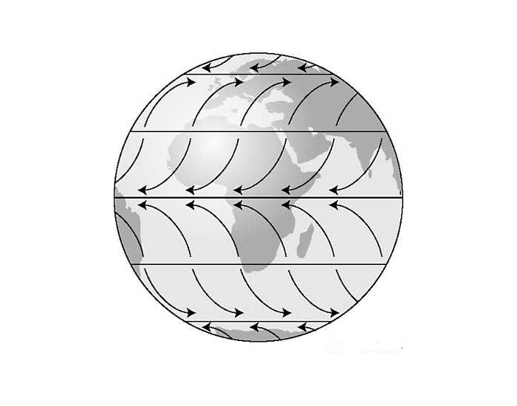
- Be able to read a weather station symbol like the one below. Know how to determine wind speed and direction.
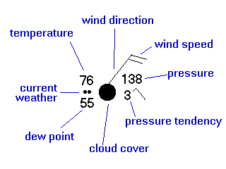

- Watch the following VIDEOS for review:
  - Climate Change Basics
    - https://www.youtube.com/watch?v=ScX29WBJI3w
  - Climate vs Weather:
    - https://www.youtube.com/watch?v=XirAUvS_29I
  - Layers of Atmosphere
    - https://www.youtube.com/watch?time_continue=38&v=WaikvaAw2nk
  - What are Weather Fronts
    - https://www.youtube.com/watch?v=G7Ewqm0YHUI

