The strength of gravity on different places in the Solar System is given in the table below.
Strength of gravity (g) on the surface, in Newtons per Kilogram (N/kg)
Mercury  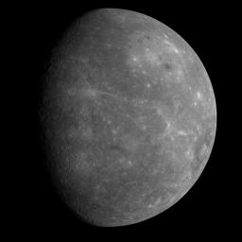 | Venus  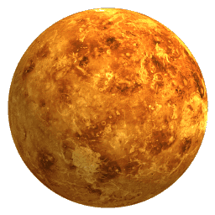 | Moon  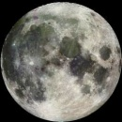 | Mars  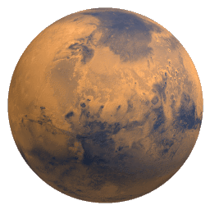 | Jupiter  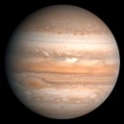 | Saturn  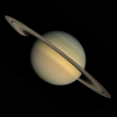 | Uranus  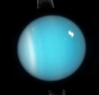 | Neptune  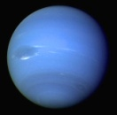 | Pluto  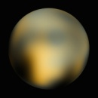
3.8 | 8.8 | 1.6 | 3.7 | 23.1 | 9.0 | 8.7 | 11.0 | 0.6
Use the formula weight = mass x g to answer the questions below.
- How much would a 10 kg suitcase weigh on the surface of…?

  - The Moon
  - Mars
  - Saturn
  - Pluto

- How much would a 25 kg suitcase weigh on the surface of…?

  - Mercury
  - Venus
  - Jupiter
  - Uranus

- What would be the mass of a 10 kg suitcase be on…?

  - Mercury
  - Venus
  - Neptune
- If you were sitting, on which place in the above table would it be easiest to stand up? Why?
- On which place from the table above would you have…?

  - The most weight
  - The most mass

- If you stood on Mars and lifted a 15 kg pack, you would be pulling with a force greater than…?
- If a 60 kg person was standing on a platform at the surface of Saturn and they jumped, they would have to push with a force greater than…?
- The Curiosity rover on Mars currently has a weight of 3,330 N. What is its mass?
- A person with mass of 60 kg standing on the dwarf planet Ceres would weigh 16.2 N. What is the strength of gravity on the surface of Ceres?
- Jupiter is made of gas (like Saturn, Uranus and Neptune). What would happen to the strength of gravity if you...?

  - Moved away from Jupiter
  - Fell in to Jupiter

