Chemical Bonding NAME: _____________________________

Valence Electrons & Groups
- Recall: Valence electrons are the electrons found in the _____________________ energy level of an atom.
- The ______________number of a specific group tells us how many valence electrons an element in that group contains.
- Examples: SODIUM (Na) is in group 1A so it has____________- valence electron.

Electron Dot Diagrams
- Stable Electron Configurations: when the highest occupied energy level of an atom is filled with ______________________-, the atom is ________________- and not likely to ________________

- All elements are trying to maintain_________________VALENCE ELECTRONS (this is considered a stable electron configuration)
- We can use Electron _____________Diagrams to help us represent the valence electrons in an atom.

Ionic Bonding
- Some elements achieve stable electron configurations through the ______________________of electrons between atoms
- This causes the formation of ________________-(an atom that has a net positive or negative electric ______________________)

Anions
- An anion is an ion with a _____________________charge.
- Atoms ____________________electrons in order to get a negative charge and form an anion
- Anions are named by using part of the element name PLUS the suffix ________________
- Ex: Cl⁻ is called a chloride ion.
- ___________________________typically form anions.

Cations
- An ion with a _____________________________charge is called a cation.
- Atoms ___________________electrons in order to gain a positive charge and form cations
- Naming a cation is easy, it is just the element ____________________.
- Ex: Na⁺ is just a sodium ion.
- _____________________-tend to form cations

Formation of Ionic Bonds
- In general, a _______________ _________________ is the force that holds atoms or ions together.
- An ___________________Bond is the force that holds cations and anions together.
- Ionic bonds are formed when electrons are ___________________________ from one atom to another
- Metals _______________ their electrons to NONMETALS.

Compounds
- A chemical ___________________is a notation that shows what elements a compound contains and the _______________of the atoms or ions of these elements in the compound.
- Example: Magnesium Chloride is written as MgCl₂

Ionic Compounds
- Compounds that contain ionic bonds are called __________________compounds.
- Elements that form ionic compounds create the same chemical formula that was in the previous slide.

Covalent Bonds
- A covalent bond is a bond in which two atoms _________________a pair of valence electrons.
- The attractions between the shared electrons and the protons in each nucleus _____________the atoms _____________________in a covalent bond.
- Covalent bonds form ________________________compounds
- A ___________________________________is a neutral group of atoms that are joined together by one or more covalent bonds.

Tug – of - War
- you might think of the bond as the rope in a tug-of-war, and the shared electrons as the knot in the center of the rope
- each atom in the molecule attracts the electrons that they share

Ionic vs. Covalent Bonds
http://www.youtube.com/watch?v=_M9khs87xQ8

Describing Molecular Compounds
- The name and formula of a molecular compound describe the _____________ and ______________________ of atoms in a molecule of the compound.

Naming Molecular Compounds
- Most ________________________ element written first
- The second element is changed to end in _______________
- Use __________________prefixes to describe the number of atoms of a given element in each molecule
Example: NO₂ = nitrogen dioxide

Writing Molecular Formulas
- Write the symbols for the elements in the order the elements appear in the name.
- The prefixes indicate the number of atoms of each element in the molecule.
- The prefixes appear as subscripts in the formula. (if there is no prefix for an element, there is only one atom of that element in the molecule)
Example: Diphosphorous tetrafluoride = P₂F₄

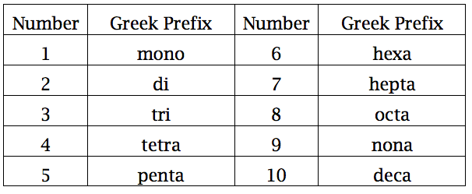

Structure of Metals
- ____________________atoms are arranged in very compact and orderly patterns.
- Usually have a _________________________structure
- Metallic in their properties and physical appearance
- Examples: Gold, _________________- Chromium, Zinc

Alloys
- Most of the metals that we encounter in everyday life are not ________________-metals.
- Alloys are ___________________composed of two or more elements, at least once of which is a __________.
- Example:
  - BRASS – most people think brass is just another element off the periodic table but it is actually not. It is an alloy that is comprised of both Silver and Copper.
  - Bronze – comprised of Copper and Tin.
- Alloys tend to be ____________________and more ________________than PURE metals.
- Most __________________ is comprised of alloys – mostly made up of silver or gold but with a little bit of other metals mixed in to make them more durable.

