Name: _____________________________ Date: __________________ Period: ___________

CHANGES OF STATE

What are Changes of State?
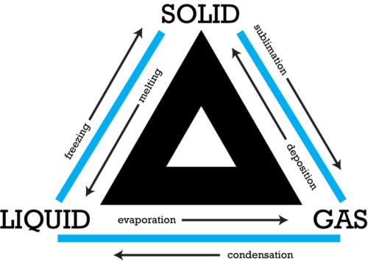
- _________________ Changes
- _______________________ changes
- Examples:
  - Melting
  - ____________________
  - Sublimation
  - ___________________
  - _________________________
  - Vaporization

Energy, Temperature & Changes of State
- Energy is always involved in changes of ___________________.
- Matter either _______________or ___________________________energy when it changes state.
- _________________________ – the average kinetic energy of the particles of matter.

Changes between Liquids & Solids
- Freezing – liquid changing into a __________________
- Liquid particles lose energy until they no longer ______________ ______________ each other.
- Once in a ____________________ position they become a solid
- Freezing point – the temperature at which a ________________changes into a ________________
  - Example: Water 0°C (32°F)

Melting
- Melting – when ______________ changes into a _________________
- Melting point – the ____________________________ at which a solid changes to a liquid.
- Melting point is the same as the _______________________ point.
- Heat of fusion - the amount of ___________________ required to change a substance from the solid phase to the liquid phase at its _____________________ ______________________

Changes between Liquids and Gases
- _____________________________– liquid changes to a gas
  - point at which the liquid breaks free of all attractive forces and changes into a _____________
    - 2 ways
      - evaporation (happens at the ___________________of the liquid) particles break away into the air without boiling
      - boiling (throughout _____________________substance)

- Boiling point
  - the temperature at which the ____________________of the ______________ in the liquid is equal to the external pressure acting on the _____________________of the liquid
- Heat of vaporization
  - the amount of _______________required for the liquid at its boiling point to become a __________

Condensation
- Condensation – gas changes to a ____________________
- Water vapor cools, _______________ ________________, forms droplets
- Examples: _____________________________________________

Changes between Solids and Gases
- Sublimation – solids change _________________________to a gas (without going through being a liquid)
- Example: ____________________________________

Deposition
- Deposition – gas changes ______________________ to a solid without going through the liquid state.
- Example: ______________________________

Heat Curve or Phase Diagram

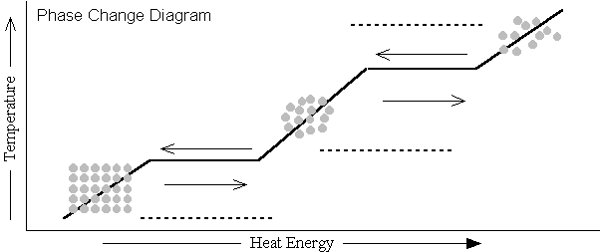

Temperature remains constant during a change in state.

